

Project - Low Level Design

On
Constructor Planning Assistant Agent

Course Name: Agentic AI

Institution Name: Medicaps University – Datagami Skill Based Course

Student Name(s) & Enrolment Number(s):

Sr no | Student Name | Enrolment Number
01 | HARDIK BASER | EN22CS301380
02 | HRICHA LAAD | EN22CS301429
03 | HARSHITA PARMAR | EN22CS301408
04 | HUZEFA BURHANI | EN22CS301432
05 | HARIOM KALE | EN22CS301381

Group Name: Group 02D4 Project Number: AAI-38 Industry Mentor Name:
University Mentor Name: Pradeep Baniya Academic Year: 2026




Introduction:
The Construction Planning Assistant Agent is an advanced Agentic AI system designed to automate and optimize construction planning processes. Traditional construction planning requires manual effort, domain expertise, and time-consuming coordination between multiple stakeholders. This project aims to reduce these challenges by introducing an intelligent system capable of understanding high-level goals and converting them into structured execution plans.

The system leverages Large Language Models (LLMs) along with agent-based orchestration frameworks to perform tasks such as:

Goal interpretation
Task decomposition
Resource allocation
Timeline generation
By simulating human-like reasoning, the system ensures efficiency, accuracy, and scalability in construction project planning.

2. Problem Statement
Construction planning involves multiple complexities such as:
- Unstructured project requirements
- Dependency between tasks
- Resource constraints
- Scheduling conflicts
Currently, these tasks are handled manually or using basic tools, which leads to:
- Inefficiency
- Human errors
- Delays in project execution
Therefore, there is a need for an automated intelligent assistant that can:
- Understand project goals
- Break them into actionable steps
- Optimize execution strategies

3. Objectives

Primary Objective:
To design and implement an AI-driven planning assistant for construction workflows.

Secondary Objectives:
- Automate task decomposition
- Improve resource utilization
- Generate optimized schedules
- Reduce manual planning effort
- Enable intelligent decision-making

4. Scope of the Project

In Scope:
- Task breakdown using AI
- Resource mapping
- Schedule generation
- API-based architecture

4. System Overview
The system functions as a multi-agent pipeline, where each module performs a specific role.

Key Features:
- Accepts user-defined goals
- Uses AI for reasoning
- Generates structured outputs

Example:
Input: “Plan foundation work”
Output:
- Task list
- Required resources
- Timeline

4. Classes in the Project
Explain this like building blocks of your system:

Main Classes
- PlannerAgent
  - Main brain of the system
  - Receives user goal
  - Coordinates all steps
- TaskDecomposer
  - Breaks high-level goal into smaller tasks
  - Example: “Permit” → Documents, approvals, submission
- ResourceManager
  - Checks availability of resources (workers, materials, tools)
  - Can use mock data or APIs
- Scheduler
  - Creates timeline and execution plan
  - Assigns tasks with deadlines
- ToolInterface
  - Connects with external tools/APIs
  - Example: database, file system, or mock services

- UserInterface (UI Layer)
  - Accepts input from user
  - Displays output (steps, schedule)

5. System Architecture

Architecture Style:
- Layered Architecture
- Agent-Based System

Layers:

1. Presentation Layer
- User Interface (UI)
- Input/Output interaction

2. Application Layer
- Planner Agent
- Task Decomposer
- Resource Manager
- Scheduler

3. Data Layer
- Database (tasks, resources, schedules)

Architecture Flow:
User → Planner → Decomposer → Resource Manager → Scheduler → Output

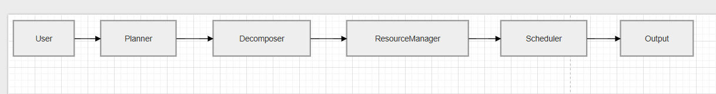

6. User Flow

Step-by-Step User Flow

1. User Interaction (Input Stage)
The user opens the application (Web UI / Streamlit / App)
Enters a construction goal
Example:
“Plan building permit process”

2. Input Validation
System checks:
Empty input
Invalid format
If invalid → shows error message
If valid → forwards to next stage

3. Planner Agent Activation
The PlannerAgent receives the user goal
Acts as the central controller
Decides which modules to call

4. Task Decomposition
The TaskDecomposer processes the goal
Uses LLM to break it into smaller tasks
Example Output:
Collect documents
Submit application
Wait for approval

5. Resource Allocation
The ResourceManager:
Checks available resources
Maps resources to tasks
Example:
Engineer → Document preparation
Officer → Approval process

6. Scheduling Process
The Scheduler:
Assigns start and end times
Orders tasks logically
Example:
Task 1 → Day 1
Task 2 → Day 3

7. Plan Generation
System combines:
Tasks
Resources
Schedule
Creates a complete execution plan

8. Output Display
Final result shown to user:
Task list
Timeline
Resource allocation

9. User Feedback (Optional)
User can:
Modify input
Regenerate plan
Save results

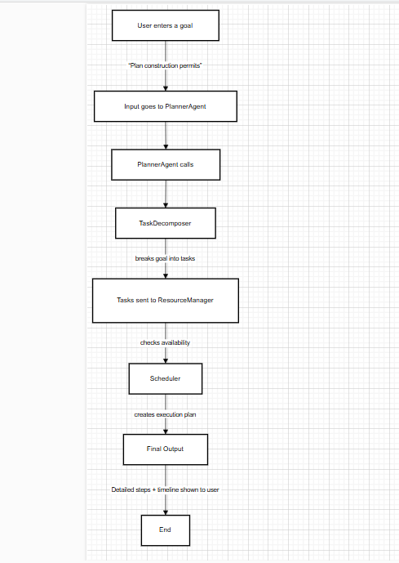

7.Data Flow

Step-by-Step Data Flow

1. User Input Data
- Input: Construction goal (text)
- Example: “Plan building permits”
This is raw unstructured data

2. Planner Agent Processing
- Receives input
- Converts it into structured format
- Passes it to Task Decomposer
Output:
Goal Object → {goal: "Plan building permits"}

3. Task Decomposer
- Uses LLM to break goal into tasks
Output:
Task List → [
"Collect documents",
"Submit application",
"Approval process"
]

4. Resource Manager
- Takes task list
- Maps resources
Output:
Resource Mapping → {
Task1: Engineer,
Task2: Clerk,
Task3: Officer
}

5. Scheduler
- Takes tasks + resources
- Assigns time
Output:
Schedule → [
{task: Task1, day: 1},
{task: Task2, day: 3}
]

6. Final Output Generator
- Combines all data
Output:
- Tasks
- Resources
- Timeline
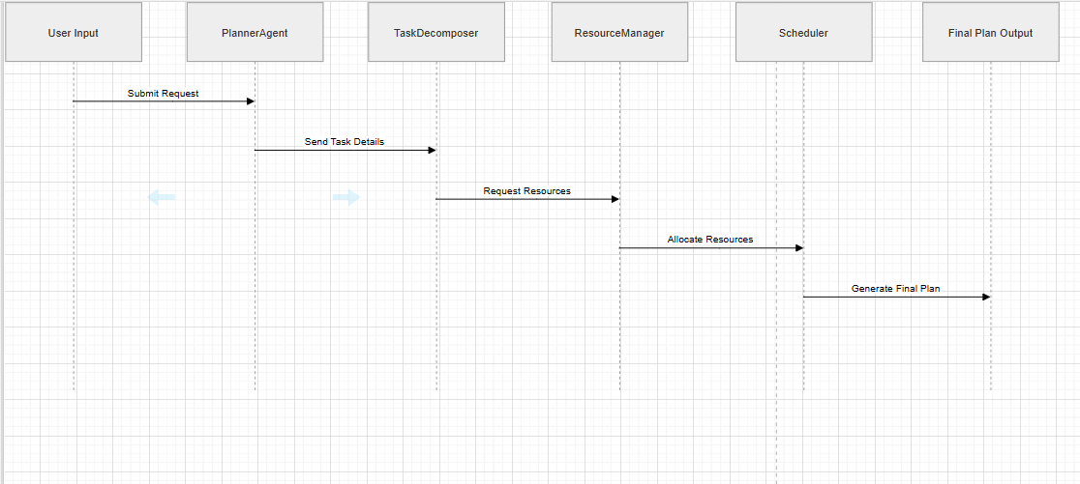

8. Entities & Relationships

Entities = Data objects used in system

Main Entities:
- User
  - Provides input
- Goal
  - High-level objective
- Task
  - Subdivided work units
- Resource
  - Workers, materials, tools
- Schedule
  - Timeline of execution

Relationships:
- One User → Multiple Goals
- One Goal → Multiple Tasks
- Each Task → Requires Resources
- Tasks → Combined into a Schedule

9. Technology Stack

Backend:
- Python
  - Easy for AI/ML
  - Large ecosystem

AI Framework:
- LangChain / CrewAI
  - Helps build multi-agent workflows
  - Supports reasoning chains

LLM API:
- Used for:
  - Task decomposition
  - Planning
  - Decision making

Database:
- SQLite / MongoDB
  - Store tasks, schedules, resources

Frontend (Optional):
- Streamlit / React
  - Simple UI for demo

CONCLUSION
“This system demonstrates how Agentic AI can automate complex construction planning by breaking down goals, managing resources, and generating intelligent schedules using multi-step reasoning.”



API REFERENCE LINKS

Resource Documentation URL

CrewAI Docs https://docs.crewai.com

LangChain Docs https://python.langchain.com

OpenAI API Reference https://platform.openai.com/docs/api-reference

Anthropic API Docs https://docs.anthropic.com/claude/reference

DuckDuckGo Search https://github.com/deedy5/duckduckgo_search

Beautiful Soup Docs https://www.crummy.com/software/BeautifulSoup/bs4/doc/

FAISS Docs https://faiss.ai/index.html

Pandas Docs https://pandas.pydata.org/docs/

